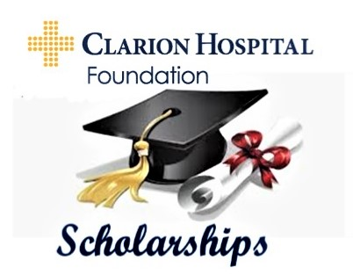
INTERESTED IN A HEALTH CARE PROFESSION?

Clarion Hospital Foundation is looking for applicants for our 2024 Scholarships.
This year we are awarding seven $1,000.00 scholarships.

$1000 Dr. John E. Brooks Memorial Scholarship was created by his family to honor his memory to benefit local students furthering their education in the field of health care.

2 - $1000 Joseph and Helen Miller Memorial Scholarships were established by the Foundation in honor of the Miller Family.

2 - $1,000 Fran Shope Memorial Scholarships to aid students in the medical field.

$1,000 James B. Alexander Memorial Scholarship for the student with the best essay.

$1,000 Dr. John L. Johnston Memorial Scholarship awarded to a student who is enrolled in or accepted to a medical school.
*The scholarships will be paid directly to the school of the student's choice in August*

To be eligible, students must meet the following criteria:

- Be a graduate or future graduate of a Clarion County high school

- Be accepted to a school of post-secondary health care education

- Have a grade point average of 3.0 or equivalent in the final three years of high school

- Plan to pursue their education in nursing, inhalation therapy, lab technology, radiology, physical therapy, occupational therapy, medical technology, or other medical field.

Mail Completed Applications To:
Clarion Hospital Foundation
1 Hospital Drive
Clarion PA, 16214

Applications must be postmarked or delivered to the foundation by FEBRUARY 29, 2024
For More Information Contact Clarion Hospital Foundation at 814-226-1258,
Find us on Facebook – Clarion Hospital Foundation, or online at
https://www.butlerhealthsystem.org/clarion-hospital/services/clarion-hospital-foundation/scholarships/

